**LED Creative Display Product Categories**

|  |  |  |  |  |  |  |  |  |  |  |  |  |  |  |  |  |  |  |
| --- | --- | --- | --- | --- | --- | --- | --- | --- | --- | --- | --- | --- | --- | --- | --- | --- | --- | --- |
| **Personalized** **LED** **display** | | | | | | | | | | | | | | | | | | |
| **LED** **Badge** | | | | **LED** **Hat** | | | | | | | | **LED** **Collar** | | **LED** **Bottle** | | | **LED** **Mask** | |
|  | |  | | WEL | |  | | 欢迎 | |  | |  | |  |  | | 1 | |
| **item#** | **color** | **item#** | **color** | **item#** | **color** | **item#** | **color** | **item#** | **color** | **item#** | **color** | **item#** | **color** | **item#** | **color** | | **item#** | **color** |
| B1248 | red | B1248BL | red | M536  (English) | Monodhrome | M1248A | Monochrome | M1248B internal | Monochro me | M1632 | RGB | C1248 | Monochrome | W1248 | Monochrome | | M1248D | Monochrome |
| blue | blue |
| green | green | pink | pink | pink | pink | pink | | pink |
| white | white |
| pink | pink | multi color | external | multi color | multi color | multi color | multi color | | multi color |
| Purple | multi single color | M1632D | RGB |
| size:93*30*6MM  pixels:44*11 dots  communication:USB-PC  Power:Lithium battery installation:pin/magnet weight:50G/set  box size:11*7*2CM  100pcs carton size:39*25*16 CM | | size:93*30*6MM  pixels:48*12 dots  communication:bluetooth APP power:lithium battery  installation:pin/magnet weight:50G/set  box size:11*7*2CM  100pcs carton size:39*25*16 CM | | size:free /adjustable  pixels:48*12 dots  communication:bluetooth APP  power:lithium battery  installation:wearable  weight:145G/set  packing size:24*23*14CM  10pcs:39*25*16CM 25pcs 62*25*19CM  100pcs:69*50*32CM | | size:free /adjustable  pixels:48*12 dots  communication:bluetooth APP  power:lithium battery  Installation:wearable  weight:160G/set  packing sire:24*23*14CM  10pcs:39*25*1CM  25pcs 62*25*19 CM  100pcs:69*50*32 CM | | size:free /adjustable  pixels:48*12 dots  communication:bluetooth APP  power:lithium battery  installation:wearable  weight:160G/set  packing size:24*23*14CM  10pcs:39*25*16 CM  25pcs:62*25*19 CM  100pcs:69*50*32 CM | | size:free /adjustable  pixels:32*16 dots  communication:bluetooth APP power:lithium battery  installation:wearable weight:180G/set  packing size:24*23*14CM  10pcs:39*25*16CM 25pcs:62*25*19CM 100pcs:69*50*32CM | | size:free /adjustable  pixels:48*12 dots  communication:bluetooth APP  power:lithium battery  installation:wearable  weight:105G/set  packing size:48*8*6 CM | | size:free /adjustable  pixes:48*12 dots  communication:bluetooth APP  power:lithium battery installation:wearable weight:55G/set  packing size:26*12*9 CM | | | size:free /adjustable  picels:48*12 dots/32*16 dots  communication:bluetooth APP  power:lithium battery installation:wearable weight:55G/set  packing size:26*15*5 CM | |
| **LED** **powerbank** | | **LED** **fannybag** | | | | | | **LED** **Backpack** | | | | **LED** **VEST** | | **LED** **T-SHIRT** | | | **LED** **frame** **screen** | |
| 移动电源 | |  | |  | | )ap | |  | |  | |  | |  | |  |  | |
| **item#** | **color** | **item#** | **color** | **item#** | **color** | **item#** | **color** | **item#** | **color** | **item#** | **color** | **item#** | **color** | **item#** | **color** | | **item#** | **color** |
| BLP801 | Monochrome | B102 | RGB | B103 | RGB | B104 | RGB | B201  (Tech Cloth) | RGB FUL  COLOR | B301  (PU leather) | RGB FULL  COLOR | T6464-1  Single-sided | full color | T1632 | RGB | | D3-6464 | RGB |
| pink | T6464-2  Double Sided | full color | D3-64128 | RGB |
| multi color |
| Size:158*75*15 MM Display  dot matric 48*12 dots  transmission mode:Bluetooth  APP  Powersupply mode:lithium battery  Installation:WearableWeight 400G/set  Package size:26*12*4CM | | Size:176*76 MM  Display lattice:32*16 dots  Transmission mode:Bluetooth APP  Power supply mode:lithium battery Installatione Wearable  Weight 450G/set  Package size:31*29*7 CM | | Size:176*76 MM  Display dot matrixc:32*16 dots  transmission mode:Bluetooth APP Power supply mode.lithium battery Installation:Wearable  Weight:450G/set  Package size:31*29*7 CM | | Size:180*180MM Display dot matric 64*64 dots  transmission mode:Bluetooth APP Powersupply mode:lithium  battery  Installation:Wearable Weight:500G/set  Packagesize:31*29*70M | | Size:260*260 MM Display dot matric 64*64 dots  transmission moder Bluetooth APP  Power supply mode:power bank Installation:Wearable  Weight:1600 G/set  Package size:48*20*36 CM | | Size:260*260 MM  Display dot matribc:64*64 dots  transmission mode:Bluetooth APP  Power supply mode:power bank Installation:Wearable  Weight:1600 G/set  Package size:48*20*36 CM  10pcs Size:47*66*64 CM | | Size:260*260 MM  Display dot matrix:48*12 dots  transmission mode:Bluetooth APP  Power supply mode power bank  Installation:Wearable Weight:140G/set  Package size:32*29*8 CM | | Size:200*260MM  Display dotmatrixc 32*16 dots transmissionmode:BluetoothAPP Power supply mode:power bank nstallation:Wearable  Weight:120G/set  Package size:32*29*8CM | | | Size:195*195*20MM 387*195*20MM  Display dotmatrix:128*64 dot  Transmission mode: WIFI  communication  Power supply moder USB cable Installation method:stand  Weight:950G/set | |
| Note: Red,yellow,blue.green,white are available for Monochrome color  Standard configuration: one led screen,one USB communication,one manual,neutral carton packaging. | | | | | | | | | | | | | | | | | | |

|  |  |  |  |  |  |  |  |  |  |  |  |  |
| --- | --- | --- | --- | --- | --- | --- | --- | --- | --- | --- | --- | --- |
| **RGB color ultra-thin flexible LED display** | | | | | | | | | | | | |
| **Picture** | **Model** | **LED** **color** | **Border** | **Pixel** | **screen** **size** | **communication** | **Power** | **Color** **box** **size** | **Weight** | **Outer** **box** **size** | **qty/box** | **G.W./box** |
| 只吧  LL  B AUTY  B AUT¹Q | S3232 | RGB | PU | 32*32 dots | 230*187mm | Bluetooth APP | 5V/12V | 23*11*10CM | 300g | 60*50*45CM | 40 | 12kg |
| S1632 | RGB | PU | 16*32 dots | 148*90 mm | Bluetooth APP | 5V/12V | 13.5*11*10CM | 250g | 60*45*25CM | 30 | 7.5kg |
| S1664 | RGB | PU | 16*64 dots | 390*107 mm | Bluetooth APP | 5V/12V | 13.5*11*10CM | 300g | 60*45*25CM | 30 | 9kg |
| S1696 | RGB | PU | 16*96 dots | 672*122 mm | Bluetooth APP | 5V/12V | 13.5*11*10CM | 400g | 60*45*25CM | 30 | 12kg |
| S3264 | RGB | PU | 32*64 dots | 390*187 mm | Bluetooth APP | 5V/12V | 23*11*10CM | 400g | 60*50*45CM | 40 | 16kg |
| S3296 | RGB | PU | 32*96 dots | 672*218 mm | Bluetooth APP | 5V/12V | 23*11*10CM | 500g | 60*50*45CM | 40 | 20kg |
| P1696 | RGB | PU | 16*96 dots | 705*130 mm | Bluetooth APP | 5V/12V | 30*25*13.5cm | 450g | 67*48*30cm | 30 | 13kg |
| P32128  (1921) | RGB | PU | 32*128 dots | 705*220 mm | Bluetooth APP | 5V/12V | 30*25*13.5cm | 800g | 67*48*30cm | 20 | 15kg |
| F1664 | RGB | PU | 16*64 dots | 276*90 mm | Bluetooth APP | 5V/12V | 13.5*11*10CM | 250g | 60*45*25CM | 30 | 7.5kg |
| F16128 | RGB | PU | 16*128 dots | 532*90 mm | Bluetooth APP | 5V/12V | 13.5*11*11CM | 500g | 60*45*25CM | 30 | 15kg |
| F16192 | RGB | PU | 16*192 dots | 788*90 mm | Bluetooth APP | 5V/12V | 13.5*11*12CM | 750g | 60*45*25CM | 30 | 22.5kg |
| F16256 | RGB | PU | 16*256 dots | 1044*90 mm | Bluetooth APP | 5V/12V | 13.5*11*13CM | 1000g | 60*45*25CM | 30 | 30kg |
| F16320 | RGB | PU | 16*320 dots | 1300*90 mm | WIFI | 5V/12V | 13.5*11*14CM | 1250g | 60*45*25CM | 30 | 37.5kg |
| F16384 | RGB | PU | 16*384 dots | 1560*90 mm | WIFI | 5V/12V | 13.5*11*15CM | 1500g | 60*45*25CM | 30 | 45kg |
| F3264 | RGB | PU | 32*64 dots | 260*150 mm | Bluetooth APP | 5V/12V | 16*11*10CM | 350g | 60*35*25CM | 20 | 7kg |
| F32128 | RGB | PU | 32*128 dots | 500*150 mm | Bluetooth APP | 5V/12V | 16*11*10CM | 700g | 60*35*25CM | 20 | 14kg |
| F32192 | RGB | PU | 32*192 dots | 740*150 mm | WIFI | 5V/12V | 16*11*10CM | 1050g | 60*35*25CM | 20 | 21kg |
| F32256 | RGB | PU | 32*256 dots | 980*150 mm | WIFI | 5V/12V | 16*11*10CM | 1400g | 60*35*25CM | 20 | 28kg |
| F32320 | RGB | PUI | 32*320 dots | 1220*150 mm | WIFI | 5V/12V | 16*11*10CM | 1750g | 60*35*25CM | 20 | 35kg |
| F32384 | RGB | PU | 32*384 dots | 1460*150 mm | WIFI | 5V/12V | 16*11*10CM | 2100g | 60*35*25CM | 20 | 42kg |

|  |  |  |  |  |  |  |  |  |  |  |  |  |
| --- | --- | --- | --- | --- | --- | --- | --- | --- | --- | --- | --- | --- |
| **Ultra-thin LED Display Products** | | | | | | | | | | | | |
| **Product** **images** | **Model** | **Color** | **Border** | **Pixel** | **Screen** **size** | **ommunication** | **Power** | **Color** **boxsize** | **Weight** | **Outer** **box** **size** | **qty/ctn** | **Weight** |
|  | K1648 | Monochrome | Aluminum frame | 48*16 points | 260*95*15 mm | Bluetooth APP | 5V/12V | 360*130*35 mm | 0.45KG | 50*44*32CM | 20 | 11kg |
| K1664 | Monochrome | Aluminum frame | 64*16 points | 340*95*15 mm | Bluetooth APP | 5V/12V | 440*130*35 mm | 0.6KG | 50*44*32CM | 20 | 14kg |
| K1680 | Monochrome | Aluminum frame | 80*16 points | 410*95*15 mm | Bluetooth APP | 5V/12V | 510*130*35 mm | 0.7KG | 56*49*32CM | 20 | 16kg |
| K1696 | Monochrome | Aluminum frame | 96*16 points | 500*95*15 mm | Bluetooth APP | 5V/12V | 595*130*35 mm | 0.7KG | 69*50*32CM | 20 | 16kg |
| K16128 | Monochrome | Aluminum frame | 128*16 points | 660*95*15 mm | Bluetooth APP | 5V/12V | 770*130*35 mm | 1.2KG | 85*17*12CM | 2 | 2.6kg |
| K16160 | Monochrome | Aluminum frame | 160*16 points | 820*95*15 mm | Bluetooth APP | 5V/12V | 925*130*35 mm | 1.35KG | 107*17*12CM | 2 | 2.9kg |
| K16192 | Monochrome | Aluminum frame | 192*16 points | 980*95*15 mm | Bluetooth APP | 5V/12V | 1080*130*35 mm | 1.55KG | 114*31*38CM | 20 | 32.5kg |
| K16224 | Monochrome | Aluminum frame | 224*16 points | 1140*95*15 mm | Bluetooth APP | 5V/12V | 1240*130*35 mm | 1.75KG | 121*31*38CM | 20 | 36kg |
|  | K16256 | Monochrome | Aluminum frame | 256*16 points | 1300*95*15 mm | Bluetooth APP | 5V/12V | 1400*135*35 mm | 1.95KG | 138*143*38CM | 10 | 40.5kg |
| K16288 | Monochrome | Aluminum frame | 288*16 points | 1460*95*15 mm | Bluetooth APP | 5V/12V | 1560*135*35 mm | 2.15KG | 153*143*38CM | 10 | 23kg |
| K16320 | Monochrome | Aluminum frame | 320*16 points | 1620*95*15 mm | Bluetooth APP | 5V/12V | 1720*135*35 mm | 2.35KG | 169*143*38CM | 10 | 24.8kg |
| K1664 | RGB | Aluminum frame | 64*16 points | 340*95*15 mm | Bluetooth APP | 5V/12V | 440*130*35 mm | 0.6KG | 50*44*32CM | 20 | 11kg |
| K1696 | RGB | Aluminum frame | 96*16 points | 500*95*15 mm | Bluetooth APP | 5V/12V | 510*130*35 mm | 0.7KG | 50*44*32CM | 20 | 14kg |
|  | K16128 | RGB | Aluminum frame | 128*16 points | 660*95*15 mm | Bluetooth APP | 5V/12V | 595*130*35 mm | 1.2KG | 56*49*32CM | 20 | 16kg |
| K16160 | RGB | Aluminum frame | 160*16 points | 820*95*15 mm | Bluetooth APP | 5V/12V | 770*130*35 mm | 1.35KG | 69*50*32CM | 20 | 16kg |
| K16192 | RGB | Aluminum frame | 192*16 points | 980*95*15 mm | Bluetooth APP | 5V/12V | 925*130*35 mm | 1.55KG | 114*31*38CM | 20 | 32.5kg |
| K16224 | RGB | Aluminum frame | 224*16 points | 1140*95*15 mm | Bluetooth APP | 5V/12V | 1080*130*35 mm | 1.75KG | 121*31*38CM | 20 | 36kg |
|  | K16256 | RGB | Aluminum frame | 256*16 points | 1300*95*15 mm | Bluetooth APP | 5V/12V | 1240*130*35 mm | 1.95KG | 138*143*38CM | 10 | 40.5kg |
| K16288 | RGB | Aluminum frame | 288*16 points | 1460*95*15 mm | Bluetooth APP | 5V/12V | 1400*135*35 mm | 2.15KG | 153*143*38CM | 10 | 23kg |
| K16320 | RGB | Aluminum frame | 320*16 points | 1620*95*15 mm | Bluetooth APP | 5V/12V | 1560*135*35 mm | 2.35KG | 169*143*38CM | 10 | 24.8kg |
| 告条屏  线发送车载 EDMHDSP | K2448 | RGB | Aluminum frame | 48*24 points | 260*156*22 mm | Bluetooth APP | 5V/12V | 1720*135*35 mm | 0.6KG | 33*41*58CM | 20 | 13kg |
| K2496 | RGB | Aluminum frame | 96*24 points | 510*156*22 mm | Bluetooth APP | 5V/12V | 645*165*50 mm | 1KG | 58*41*58CM | 20 | 21kg |
| K24144 | RGB | Aluminum frame | 144*24 points | 750*156*22 mm | Bluetooth APP | 5V/12V | 910*165*50 mm | 1.6KG | 82*41*58CM | 20 | 33kg |
| K24192 | RGB | Aluminum frame | 192*24 points | 990*156*22 mm | Bluetooth APP | 5V/12V | 1040*165*50 mm | 2.2KG | 105*22*58CM | 10 | 23kg |
| K24240 | RGB | Aluminum frame | 240*24 points | 1130*156*22 mm | Bluetooth APP | 5V/12V | 1280*165*50 mm | 2.9KG | 118*22*58CM | 10 | 30kg |
|  | K24288 | RGB | Aluminum frame | 288*24 points | 1470*156*22 mm | Bluetooth APP | 5V/12V | 1620*165*50 mm | 3.2KG | 153*22*58CM | 10 | 33kg |

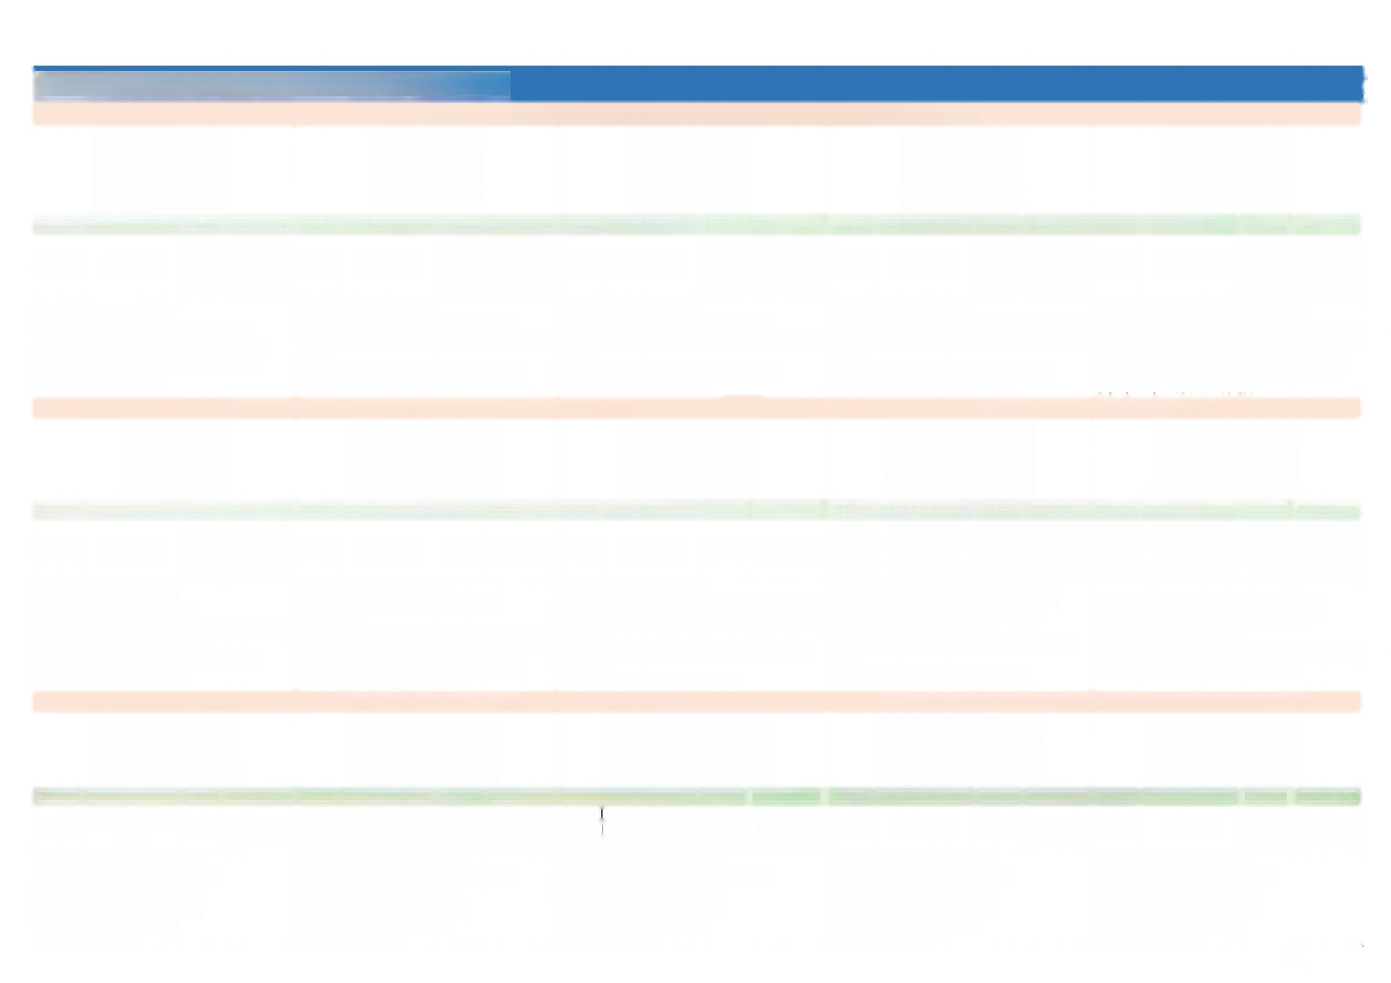

|  |  |  |  |  |  |  |  |  |  |  |  |  |  |  |  |  |  |  |
| --- | --- | --- | --- | --- | --- | --- | --- | --- | --- | --- | --- | --- | --- | --- | --- | --- | --- | --- |
| **Vehicle** **LED** **Display** | | | | | | | | | | | | | | | | | | |
| **Mini** **LED** **car** **screen(European** **and** **American** **remote** **control** **version)** | | | | | | | | | | | | | | | | | | |
|  | | |  | | | |  | | | |  | | | |  | | | |
| **Model** | **Screen** **size** **MM** | **Color** | **Model** | **Screen** **size** **MM** | **Color** | **Color** | **Model** | **Screen** **size** **MM** | **Color** | **Color** | **Model** | **Screen** **size** **MM** | **Color** | **Color** | **Model** | S**creen** **size** **MM** | **Color** | **Color** |
| Z723 | 133*33*7 | Red | Z740 | 340*50*10 | Red | Red | Z741 | 230*50*10 | Red | Red | B741 | 288*80*15 | Red | Red | D750 | 433*95*66 | Red | Red |
| Blue | Blue | Blue | Blue | Blue | Blue | Blue | Blue | Blue |
| White | White | White | White | White | White | White | White | White |
| Pink | Pink | Pink | Pink | Pink | Pink | Pink | Pink | Pink |
| Display lattice:23*7 dots  Transmission mode:remote control input  Power supply mode:12 V red and black wire  Installation method:suction cup(standard)  Packagesize:20*14 CM | | | Display lattice:40*7 dots  Transmission mode:remote control input  Power supply mode:12V cigarette lighter with car cable  Installation method:suction cup(standard)  Color box size:32*6*14 CM | | | | Display lattice:41*7 dots  Transmission mode:remote control input  Power supply mode:12V cigarette lighter withcar cable  Installation method:suction cup (standard)  Color box size:28*6*7 CM | | | | Display lattice:41*7 dots  Transmission mode:USB+remote control input  Power supply mode:12V cigarette lighter with car cable  Installation method:suction cup (standard)  Color boxsize:338*100*30 MM | | | | Display dot matrix:50*7 dots  Transmission mode:remote control input  Power supply mode:12V cigarette lighter with car cable  Installation method:double-sided adhesive tape (standard) | | | |
| **Mini** **LED** **car** **screen(multi-language** **app** **version**) | | | | | | | | | | | **Rear** **window** **LED** **car** **display** | | | | | | | |
|  | | |  | | | | D1272 BL | | | | **彩** **色** **车** **扩** **告** **屏** | | | | 大 Insp | | | |
| **Model** | S**creen** **size** **MM** | **Color** | **Model** | | **Screen** **size** **MM** | **Color** | | **Model** | S**creen** **size** **MM** | **Color** | | **Model** | **Screen** **size** **MM** | **Color** | | **Model** | **Screen** **size** **MM** | **Color** | |
| Z1272 | 230*50*10 | Red | X1272 | 360*90*15 | RGB | | D1272 | 433*95*66 | Color | | K1664 | 340*95*15 | RGB | | K2448 | 260*160*22 | RGB | |
| Blue | K1696 | 500*95*15 | RGB | | K2496 | 510*160*22 | RGB | |
| White | K1612 | 660*95*15 | RGB | | K24144 | 750*160*22 | RGB | |
| Pink | K1616 | 820*95*15 | RGB | | K24192 | 990*156*22 | RGB | |
| Display lattice:72*12 dots  Transmission mode:APP input  Power supply mode:12V cigarette lighter with car cable  Installation method:suction cup (standard)  Color box size:28*6*7 CM | | | Display lattice:72*12 dots  Transmission mode:mobile phoneAPP transmission  Power supply mode:12Vcigarette lighter with car cable  Installation method:suction cup(standard)  Color box size:51*13*35 CM | | | | Display lattice:72*12 dots  Transmission mode:mobile phone APP transmission  Power supply mode:12V cigarette lighter with car cable  Installation method:double-sided adhesive tape (standard)  Color box size:483*125*100MM | | | | Display dot matrix.64/96/128/160*16 dots  Transmission mode:WIFI communication Power supply mode:adapter  Installation method:hanging chain and suction  cup  Weight:600G/700G/1200G/1350G/set | | | | Display dot matrix:48/96/144/192*24 dots  Transmission mode:WIFI communication Power supply mode:adapter  Installation method:hanging chain and suction cup Weight:600G/1000G/1600G/2200G/set | | | |
| **LED** **expression** **screen** | | | | | | | | | | | **Intelligent** **tail** **lights** **for** **bicycles** **and** **electric** **vehicles** | | | | | | | |
|  | | |  | | | |  | | | | **《** | | | |  | | | |
| **Model** | **Screen** **size** **MM** | **Color** | **Model** | **Screen** **size** **MM** | **Color** | | **Model** S**creen** **size** **MM** | | **Color** | | **Model** | **Screen** **size** **MM** | **Color** | | **Model** | **Screen** **size** **MM** | **Color** | |
| P225 | Diameter 225 MM | RGB | P3201 | 150*150*22 | RGB | | P2541 185*185*22 | | RGB | | BK1248 | 225*5*15 | RGB | | BK536 | 195*3*15 | Monoch rome | |
| P3202 | 180*180*22 | RGB | | P3402 215*215*22 | | RGB | |
| P3203 | 210*210*22 | RGB | | P4403 280*280*22 | | RGB | |
| Display dot matrix:48*48 dots  Transmission mode:bluetooth APP  Power supply mode:USB cable  Installation method:suction cup Package size:25*25*8cm  Weight:750G/set | | | Display dot matrix:32*32 dots  Transmission mode:WIFI communication  Power supply mode:USB cable  nstallation method:suctioncup  Package size:26*24*7 CM Weight 650G/set | | | | Display dot matrix:64*64 dots  Transmission mode:WIFI communication  Power supply mode:USB cable  Installation method:suction cup  Package size:26*24*7 CM Weight 650G/set | | | | Displaydot matrix48*12 dots  Transmission mode:bluetooth APP Power supply mode:USB cable  Installation method:suction cup Package size:26*24*7 CM  Weight:650G/set | | | | Display dot matrix:36*5 dots  Transmission mode:bluetooth APP  Powersupply mode:USB cable  Installation method:suction cup  Package size:26*24*7 CM Weight:650G/set | | | |

|  |  |  |  |  |  |  |  |  |  |  |  |  |  |  |  |  |  |  |  |
| --- | --- | --- | --- | --- | --- | --- | --- | --- | --- | --- | --- | --- | --- | --- | --- | --- | --- | --- | --- |
| **Desktop LED Display Products** | | | | | | | | | | | | | | | | | | | |
| **LED** **desktop** **screen(dot** **matrix** **series)** | | | | | | | | **LED** **Desktop** **Screen(SMT** **Series)** | | | | | | | | | | | |
| **C1648** | | **C1664** | | **C1696** | | **C16128** | | **B1664** | | **B1696** | | **B16128** | | **S1664** | | **S1696** | | **S16128** | |
|  | |  | |  | |  | |  | |  | |  | |  | |  | |  | |
| **Color** |  | **Color** | **Unit** **Price** | Color | **Unit** **Price** | Colot | Unit Price | Color | **Unit** **Price** | Color | **Unit** **Price** | Color | **Unit** **Price** | **Color** | **Unit** **Price** | **Color** | **Unit** **Price** | **Color** | **Unit** **Price** |
| Red |  | Red | USs207 | Red | US$26.92 | Red | US$33.08 | Red | US$13.08 | Red | US$16.62 | Red | US$19.38 | Red | US$20.92 | Red | US$24.62 | Red | US$27.69 |
| Yellow |  | Yellow | US$23.85 | Yellow | US$33.08 | Yellow | US$35.08 | Blue | US$13.85 | Blue | US$17.69 | Blue | USs2077 | Blue | US$24.31 | Blue | US$28.15 | Blue | US$31.54 |
| Blue |  | Blue | US$33.08 | Blue | US$45.54 | Blue | US$55.08 | Green | US$14.62 | Green | US$20.00 | Green | US$22.77 | Molow | US$24.31 | yellow | US$28 | y ow | US$31.54 |
| Green |  | Green | US$40.77 | Green | US$47.69 | Green | US$56.15 | White | US$14.62 | White | US$20.00 | White | US$22.77 | Green | US$25.38 | Green | US$30.00 | Green | US$34.62 |
| RGY |  | RGY | US$23.85 | RGY | uss30.46 | RGY | US536.15 | Yellow | US$14.62 | Yellow | US$20.00 | Yellow | US$22.77 | White | US$25.38 | White | US$30.00 | White | US$34.62 |
| RBP |  | RBP | US$39.69 | RBP | US$51.54 | RBP | US$64.62 | Pink | US$20.77 | Pink | US$28.92 | Pink | US$33.85 | Pink | US$33.08 | Pink | US$42.31 | Pink | US$48.92 |
| Size:236*110*22 MM  Display dot matrix:48*16 dots  fransmission mode:USB communication  Power supply mode Lithium battery | | Size:300*110*22 MM  Displaydotmatrix 64*16 dots  Transmkssion mode uis  communication Power supply  node:Lithium battery  Package size:50*44*32 CM | | Size:430*110*22 MM  Display dotmatrix 96*16 dots  Transmission mode:USB  communication Power supply mode:Lithium battery  Package size:56*49*32 CM | | Size:560*110*22 MM  Display dot matrix 128*16 dots D ransmission mode:USB  ommunication Power supply mode:Lithium battery  Package size:69*50*32 CM | | Size:220*76*18 MM  isplay dot matrix 48*12 dots Transmission mode:USB  communication Power supply  mode:lithium battery Package size:34*8*3cm | | Size:320*76*18MM  Displaydot matrix:72*12 dots Transmission mode:USB  communication Power supply  mode:lithium battery  Package size:45*14*4.5cm | | Size:420*76*18 MM  Display dotmatric:96*12 dots Transmission mode:USB  communication Power supply  mode:lithium battery  Package size:55*14*4.5cm | | Size:260*112*22 MM  Display dot matrix:48*12 dots Transmission mode:USB  communication Power supply  mode:lithium battery  Single size:50*44*32 CM | | Size:360*112*22 MM  Display dot matrix:72*12 dots  Transmission mode:USB  communication Power supply mode:lithium battery  Single size:56*49*32 CM | | Size:460*112*22 MM  Display dot matrixc 96*12 dots Transmission mode:USB  communication Power supply mode:lithium battery  Single size:69*50*32 CM | |
| **LEDDesktop** **Screen(SMT** **Series)** | | | | | | | | **LED** **triangle** **conference** **screen** | | | | | | | | | | | |
| **CB1664** | | **CB1696** | | **CB16128** | | **CB16160** | | **BS1664** | | **BS1696** | | **BS16128** | | **KS1664** | | **KS3264** | | **KS32128** | |
|  | |  | |  | |  | |  | |  | |  | |  | |  | |  | |
| **Color** | Red,Blue,Green,White,Yellow,Pink | **Color** | Red,Blue,Green,White,Yellow,Pink | **Color** | Red,Blue,Green,White,Yellow,Pink | **Color** | Red,Blue,Green,White,Yellow,Pink | **Color** | Red,White,Pink | **Color** | Red,White,Pink | **Color** | Red,White,Pink | **Color** | Monochrome,Color | **colo** | Color | **Color** | Color |
| Size:180*54*18MM  Display dot matrix:64*16 dots  Transmission mode:USB communication  Power supply mode:lithium battery  Package size:36*14*4.5cm | | Size:260*54*18 MM  Display dot matrix 96*16 dots  Transmission mode:USB ommunication  Power supply mode:lithium battery  Package size:45*14*4.5cm | | Size:340*54*18 MM  Display dot matrix:128*16 dots  Transmission mode:USB communication  Powersupply mode:lithium battery  Package size:55*14*4.5cm | | Size:420*54*18 MM  Display dot matrix:160*16 dots transmission mode:USB  communication  Power supply mode:lithium battery  Package size:55*14*4.5cm | | Size:220*76*85MM  Display dotmatrix:48*12 dots  Transmission mode USB  Communication  Power suppy mode:Lithium battery  Package size:27*15*13 CM | | Size:320*76*85MM  Displaydot matrix:72*12 dots  Transmission mode USB communication,  Power supply mode:Lithium battery  Package size:35*14*14 CM | | Size:420*76*85MM  Display dot matrix:96*12 dots  Transmission mode:USB  communication  Power supply mode:lithium battery  Package size:68*16*5cm | | Size:340*128*128MM  Display dot matrix:64*16 dots Transmission mode:WIFI+USB Power supply mode:Lithium battery  package size:35*14*14 CM | | Size:185*128*128MM  Displaydot matrix:64*32 dots Transmission mode:WIFI+U disk  Power supply mode Lithium battery  Package size:55*36*26 CM | | Size:340*128*128MM  Display dot matrix:128*32 dots spoints  Transmission mode:WIFI U disk  Power supply mode:  Lithium battery  Package size:55*36*26CM | |

|  |  |  |  |  |  |  |  |  |  |  |  |  |  |
| --- | --- | --- | --- | --- | --- | --- | --- | --- | --- | --- | --- | --- | --- |
| **Personalized LED Display** | | | | | | | | | | | | | |
| **LED** **handheld** **sign** **(rechargeable)** | | | | | | | | | | | **LED** **community** **screen** | | |
| 一  周杰伦 | | | | 01 | | | **手举广告** **活动推** | | | |  | | |
| **Model** | **Screen** **size** | **Color** | | **Model** | **Screen** **size** | **Color** | **Model** | **Screen** **size** | **Color** | | **Model** | **Screen** **size** | **Color** |
|  |  |  |  | C1664 | 310*110*22mm | RGY |  |  |  |  |  |  | Single-sided |
| C6464 | 285*285*22mm | RGB | | C1696 | 430*110*22mm | RGY | P4-64128 | 150*530*22mm | RGB | | C64128 | 530*270*22mm | Two-sided |
| C16128 | 560*110*22mm | RGY | Other sizes are customized |
| Display dot matrix:64*64 dots  Transmission mode:WIFI communication  Power supply mode:lithium battery Installation method:hand-held  Package size:32*32*6 CM | | | | Display lattice:128*16 dots  Transmission mode:USB communication  Power supply mode:lithium battery Installation method:hand-held  Package size:69*50*32 CM | | | Display lattice:128*64 dots  Transmission mode:WIFI communication  Power supply mode:lithium battery Installation method:hand-held  Package size:550*180*50MM | | | | Display lattice:128*64 dots  Transmission mode:WIFI communication  Power supply mode:USB cable Installation method:hanging Package size:540*280*32 | | |
| **LED** **welcome** **screen** **board** | | | | **LED** **tobacco** **screen** | | | **LED** **magic** **cube** **screen** | | | | **Logo** **screen** | | |
| 欢迎光临 欢迎  LCOME | | | |  | | |  | | | |  | | |
| **Model** | **Screen** **size** | **Color** | | **Model** | **Screen** **size** | **Color** | **Model** | **Screen** **size** | **Color** | | **Model** | **Screen** **size** | **Color** |
| F475- 160128 | 800*648*50mm | Red | | B12432 | 1150*28*20mm | Red White  Pink | P25-128F5 | 320*320*320mm | full color | | P460 | 770*110mm | full color |
| P3-128F5 | 384x384x384mm | full color | |
| RGY | | B12540 | 1430*28*20mm | Red White  Pink |
| P4-128F5 | 512x512x512mm | full color | |
| Display dot matrix:192*256 dots  Transmission mode:U disk  Power supply mode:AC110V-220V  Installation method:floor stand (standard configuration)  Package size:650*840*100MM | | | | Display lattice:432*12 o'clock/540*12 o'clock  Transmission mode:U disk  Power supply mode:AC110V-220V Package size:1200*50*40MM | | | Display lattice:128*128*5 sides Transmission mode:WIFI  Power supply mode:AC110V-220V  Installation method:side hanging on four sides  Package size:350*350*350 MM | | | | Display dot matrix:128*128 dots  Transmission mode:WIFI communication  Power supply mode:AC110V-220V  Installation method:side-mounted bracket Package size:820*160MM | | |

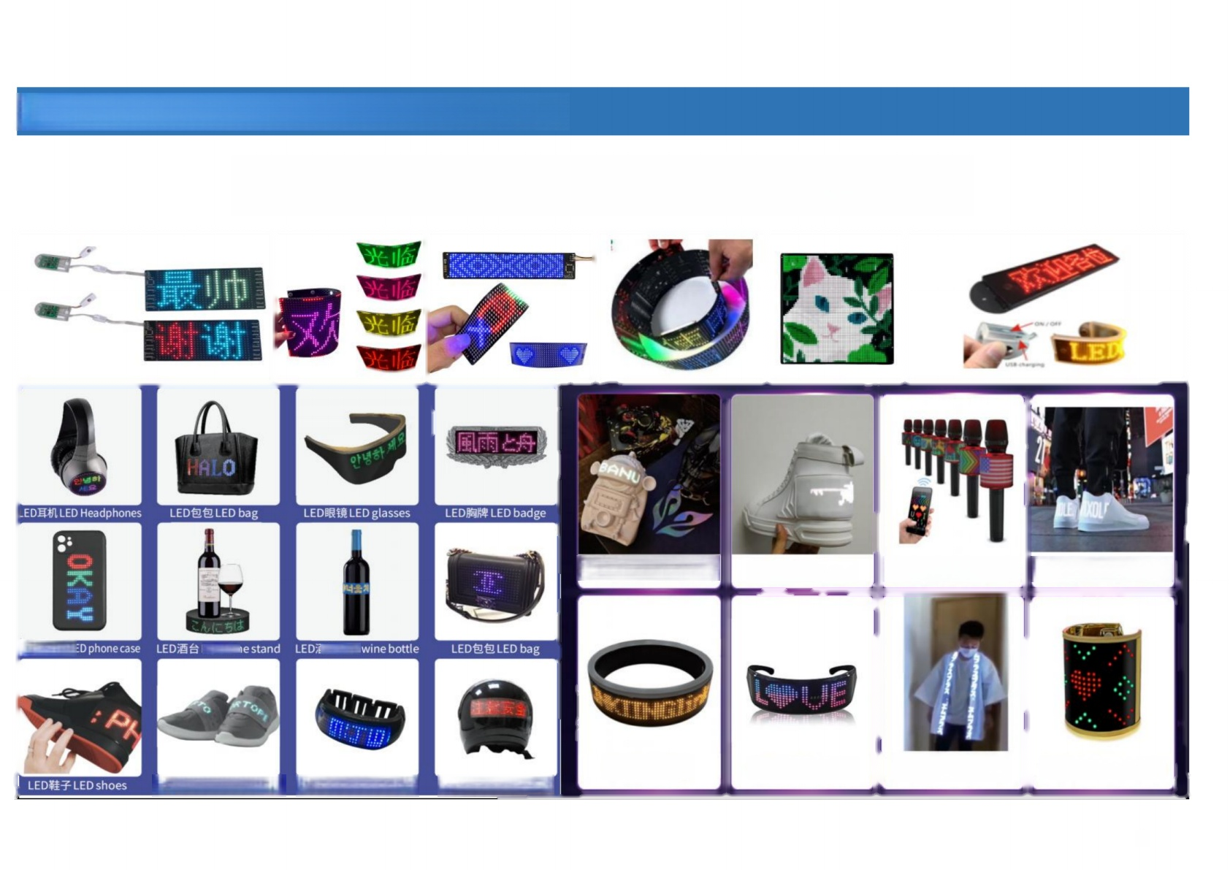

**OEM Customized LED Display Product**

**Customized LED display upon request**

|  |  |  |  |  |  |  |  |  |  |
| --- | --- | --- | --- | --- | --- | --- | --- | --- | --- |
|  |  |  | |  | |  | |  | |
| ED手机壳L  LED童鞋LED children's shoes LED手环LED bracelet | | LED头盔LED helmet | **镇至3D挎包Shoulder** **bag**  镶至圆环Ring | |  | | 镇至发光话筒Microphon | | 镇至潮流板鞋Skate shoes |
| **镶至眼镜Glasses** | | **镶至衣服Clothing** | | 镶至手环Wristband |

8